NORFOLK ISLAND - CONVICT CULTURE WEEK & ‘DANCING IN FETTERS’
20 - 25 MAY 2023
TASMANIAN TUNES SESSION

- VICTORIA LAING’S WALTZ
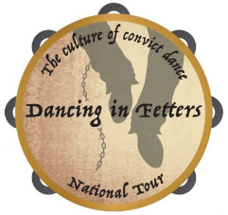
- MISS MARY STIRLING’S HORNPIPE
- MISS W. DOWNIE’S HORNPIPE
- LACHLAN VILLAGE NEAR NEW NORFOLK
- MISS VICTORIA LAING’S BIRTHDAY 19/4/1851
- CLAUDE ROAD SCHOTTISCHE
- MARK WALTERS SET TUNE
- BILL SPRATLING’S BANJO-MANDOLIN
- THE CYPRUS BRIG
NOTES ABOUT THE PEOPLE AND TUNES
- CAPE BARREN TUNES
- PETTY GOAT
- BLACK CAT PIDDLED IN THE WHITE CAT’S EYE
- UNCLE AFFIE’S TAP DANCE

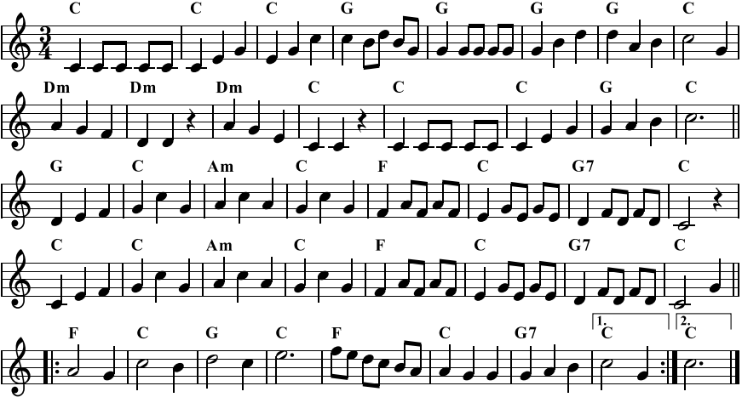
John Tomlin and Trish Williams are Hobart-based musicians who play as a duo and with various other groups covering a range of genres of ‘folk’ origin, including Australian dance tunes. The tunes compiled in this session sheet are from Tasmanian sources and have been prepared to promote the playing of the tunes at the session and for private use. Permission to copy or use for other purposes cannot be assumed.
1. VICTORIA LAING’S WALTZ [key - C]
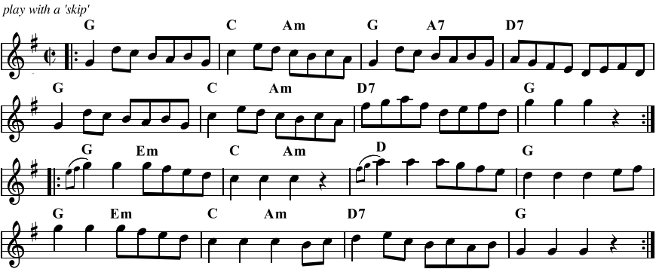
2. MISS MARY STIRLING’S HORNPIPE [key - G]
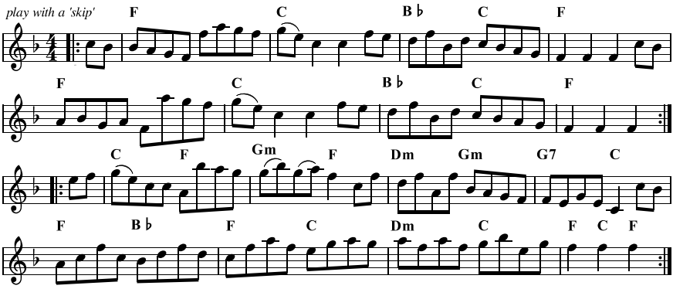
3. MISS W. DOWNIE’S HORNPIPE [key - F]

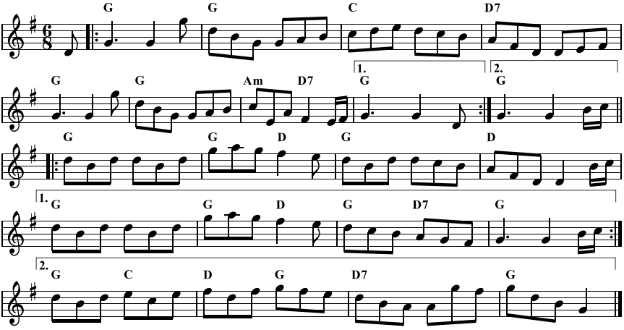
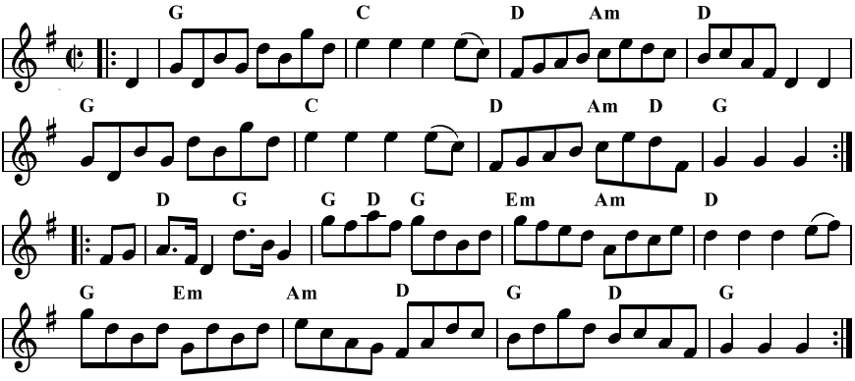
4. LACHLAN VILLAGE NEAR NEW NORFOLK [key - G]
5. MISS VICTORIA LAING’S BIRTHDAY 19/4/1851 [key - G]
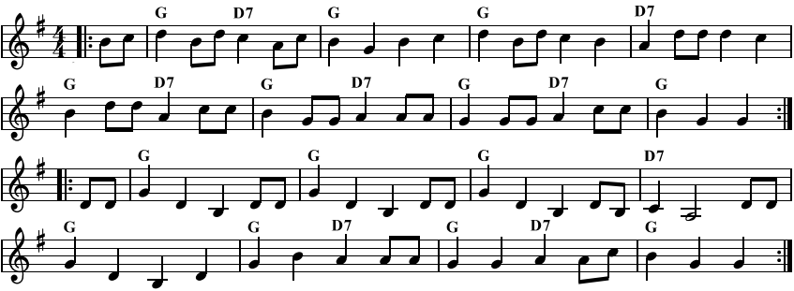
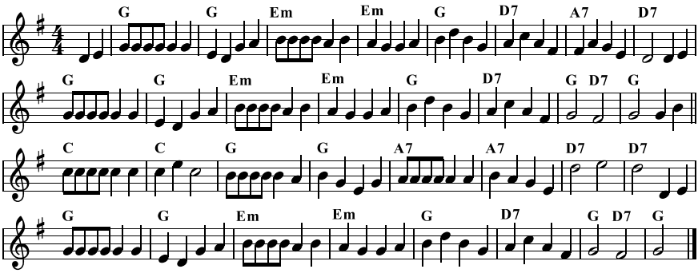
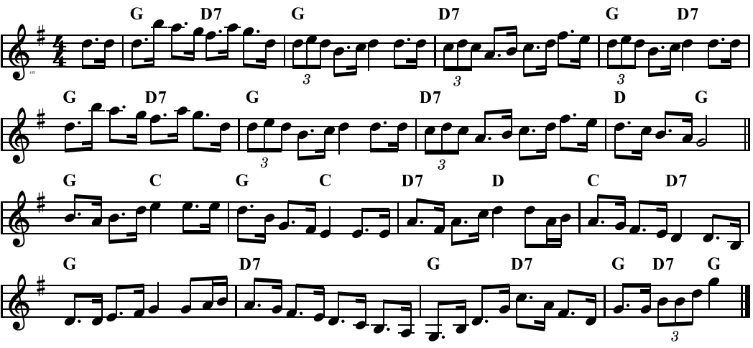
7. MARK WALTERS SET TUNE [key - G]
8. BILL SPRATLING’S BANJO-MANDOLIN [key - G]
6. CLAUDE ROAD SCHOTTISCHE [key - G]

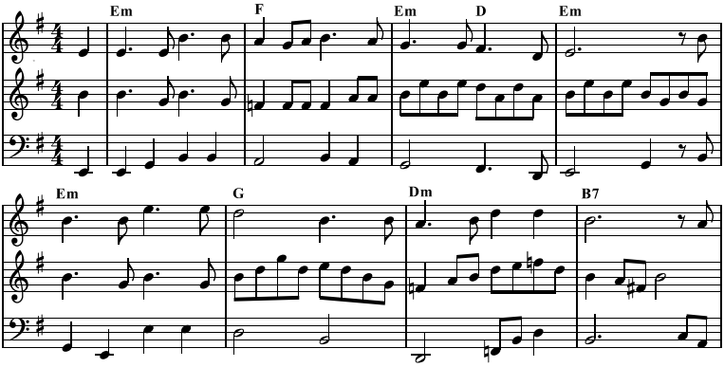
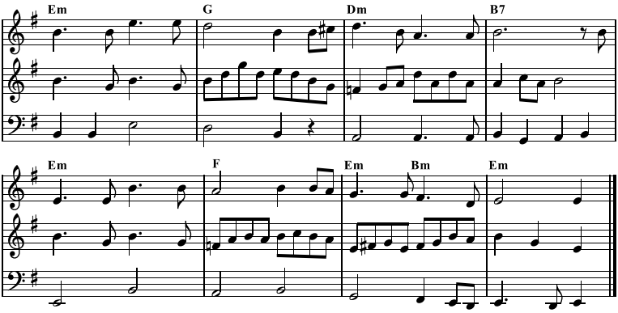
9. THE CYPRUS BRIG [key - Em]
PART 1
PART 2
CELLO

NOTES ABOUT THE PEOPLE AND TUNES

ALEXANDER LAING
- Laing was born in 1792 (d.1868) in Forfarshire Scotland and he started playing the fiddle as a young child. He joined the army in 1810 but, charged with stealing, was one of two hundred convicts transported in August 1814 on the ‘Marquis of Wellington’ to New South Wales, and then to Tasmania in 1815. By March 1816, he had married and was assigned to work near to where the town of Sorell was soon to be formed, approx. 20km east of Hobart.
- By 1821, he was Gaoler and Chief District Constable at Sorell, being posted to various localities around Southern Tasmania including Hobart, New Norfolk, Richmond and Port Arthur.
- Contemporary records have shown his reputation in a much less honourable light. On December 9th, 1826, he was involved in pursuing and killing around fourteen aboriginals in the Sorell area.
- He married twice and had twelve children. In an effort to right old wrongs, Laing tried to acknowledge his loyalty to the Crown by naming his children after British royalty.
- His style of playing reflected his Scottish music background and he wrote many pieces, including reels, jigs, strathspeys, hornpipes, waltzes, marches. Most tunes were named after local characters, places and occasions, most likely to ingratiate himself with the community.
- In 1863, he compiled a manuscript of 242 of ‘his’ tunes. Only a copy is now known, having been found at the Tasmanian Archives in 2004.
…cont.

- In 2009, historian Peter MacFie (late Cambridge, TAS, passed away April 2022), and Steve and Marjorie Gadd (Franklin, TAS) (see below) published a book called ‘On the Fiddle from Scotland to Tasmania 1815-1863’, which outlined Laing’s life and included what was identified at that time as 65 originals from the Laing manuscript.
- The book was launched at the National Folk Festival in Canberra that year. Since then, a number of those ‘originals’ have been found to have originated from primarily Scottish melodies, along with English and Irish sources.

‘VICTORIA LAING’S WALTZ’ & ‘MISS VICTORIA LAING’S BIRTHDAY 18/4/1851’
- Victoria was one of Alexander Laing’s children (see above) and was born on this date. He also dedicated two tunes to a son, somewhat predictably being called Albert Laing’s Waltz and Albert Laing’s Birthday 15/2/1855.

‘MISS MARY STIRLING’S HORNPIPE’ - details not known

‘MISS W. DOWNIE’S HORNIPE’
- She was the daughter of Mary A. Downie and her husband, William Downie, who were both born in Stirling, Scotland. They lived near Gretna, TAS, and New Norfolk by 1854 (at now historic home ‘Glen Derwent’), where Alexander Laing was then living.

‘LACHLAN VILLAGE NEAR NEW NORFOLK’
- Located approx. 6km south of the town

‘CLAUDE ROAD SCHOTTISCHE’
- Collected from Gordon Powell, Devonport TAS. Claude Road is in north-west Tasmania, linking Sheffield and Gowrie Park, and passing Mount Roland.
- Gordon Powell was born 1928 in Montana, near Deloraine. He played finger picking guitar (later electric), influenced by seeing Tex Morton (a well-known Country and Western artist) about 1936. He learnt tunes from his father, and also friends Leo Donahue and Jack Dawson. Leo wrote a song about Gordon and his guitar picking. Gordon didn’t start playing for dances until the 1960’s.
- Incidentally, Rob Willis recorded Gordon in 1994 playing ‘Gordon Powell’s No.2’ and another tune (‘No.1’), both named as schottisches. More recently, Steve Gadd transcribed the tunes and identified tune No.2 as a polka.

STEVE & MARJORIE GADD
- Both are Tasmanian-born, and Steve is a 6th generation Tasmanian. Whilst being an academic and a music teacher respectively, they were also active folk musicians playing with groups and involved with the Cygnet Folk Festival and Franklin Folk Club.
- Steve plays finger style guitar, banjo, mandolin, while Marjorie primarily plays fiddle.
- They established the ‘Tasmanian Heritage Fiddle Ensemble’ in the 1990’s and currently lead the ‘Huon Heritage at Home’ ensemble, both groups encouraging young students and adults to play Tasmanian music.
- In 2009, with historian Peter MacFie, they published a compilation of Alexander Laing tunes (see above).
- Since retiring more recently, they are very occupied with music history, recording Tasmanian tunes, composing and writing.

MARK WALTERS
- Elizabeth Goldsmith was transported to Norfolk Island for highway robbery (!) in 1789. Her granddaughter Elizabeth (nee Beazle) married convict Charles Walters (also known as Waters) who had been transported to Van Dieman’s Land in 1831 for ‘machine breaking and sheep stealing’.
- Like many others, Charles Walters attempted to hide his convict origins, but his convict record and marriage certificate show he used both Walters and Waters names when he lived in the New Norfolk / Hobart area.
- Charles and Elizabeth moved to the Deloraine Parish in north-west Tasmania after their marriage and thereafter used the name Walters. They had many descendants and Mark Walters was one of these. He served in France during WW1 and brought this tune (of unknown origin) to Tasmania on his return.
- Our friend Bronwyn Meikle’s grandfather was Oscar Alfred Walters, who was a cousin to Mark Walters.

BILL SPRATLING
- Bill was born in 1918. He was interviewed by John Meredith in Tumbarumba NSW in 1986, who recorded Bill’s playing of this tune. Steve Gadd understands Bill lived and played in the Derwent Valley, Tasmania during the 1950’s. The tune’s origin was unknown when it was sourced from a recording of him playing it on his banjo-mandolin, hence the name. It was later identified as being derived from the song ‘One Dozen Roses’ (Dick Jurgens & others, 1942).

‘THE CYPRUS BRIG’
- In 1961, Lloyd Robson recorded Jack Davies, New Town TAS, singing this song, which was derived from possibly an earlier Irish version. This version was arranged by the Gadd’s (see above), from the singing of Danny Spooner.

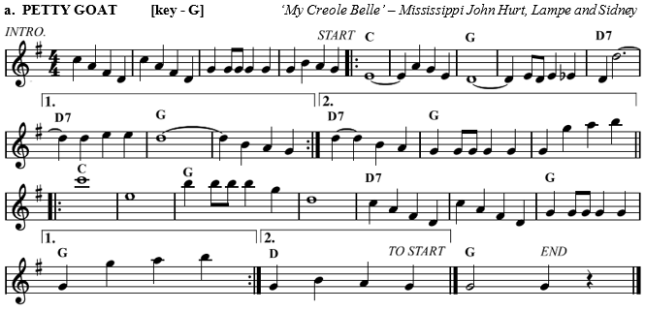
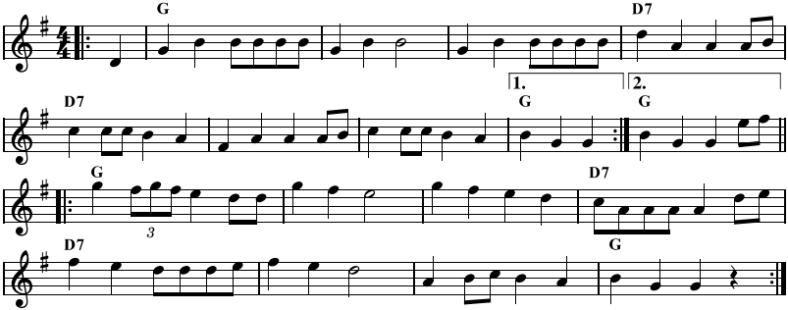
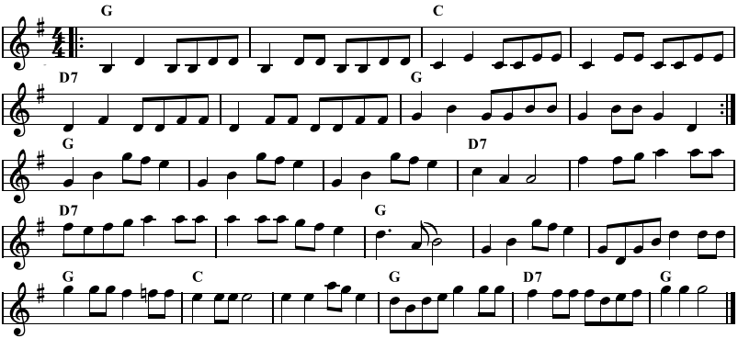
10. CAPE BARREN TUNES

The name describes the style of music that evolved and was played on Cape Barren Island by descendants of the Tasmanian indigenous people. Many of their tunes and songs were sourced from passing sailors, from vinyl etc, and fortunately were recorded in the 1970’s and later. Their music is still played by musicians across the state.
Well known players included Les, Dennis and Norman Brown, Daryl Maynard, Laurie Lowery, and Ronnie Summers.

a. PETTY GOAT [key - G] ‘My Creole Belle’ – Mississippi John Hurt, Lampe and Sidney
b. BLACK CAT PIDDLED IN THE WHITE CAT’S EYE [key - G] based on ‘Winster Galop’
a. PETTYGOAT [key - G] ‘My Creole Belle’ - Mississippi John Hurt, Lampe and Sidney
c. UNCLE AFFIE’S TAP DANCE [key - G] based on ‘Orange Blossom Special’

